# CS 255 System Design Document Template

## UML Diagrams

### UML Use Case Diagram

### UML Activity Diagrams

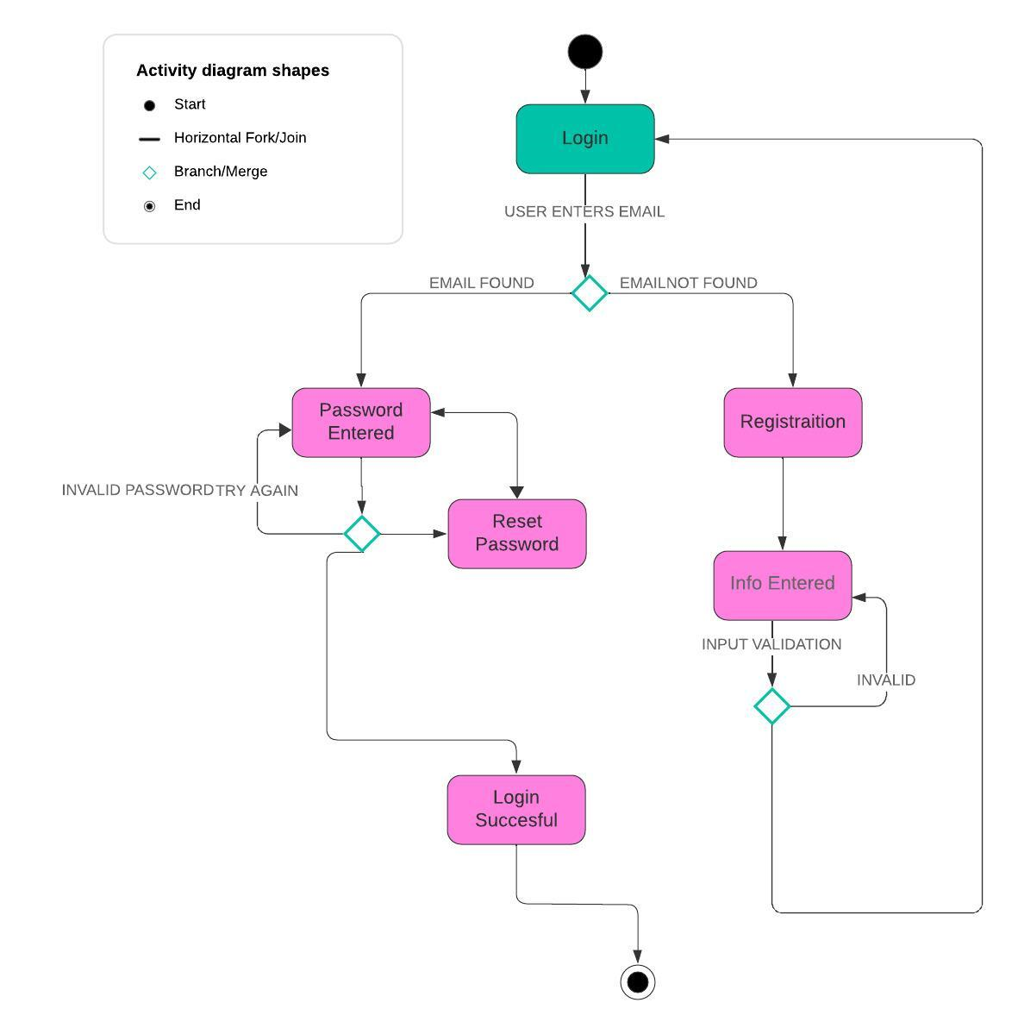

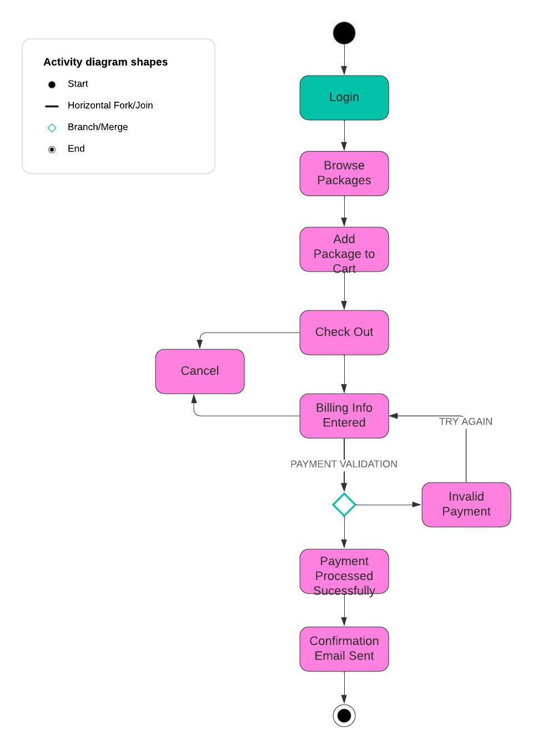

### UML Sequence Diagram

*[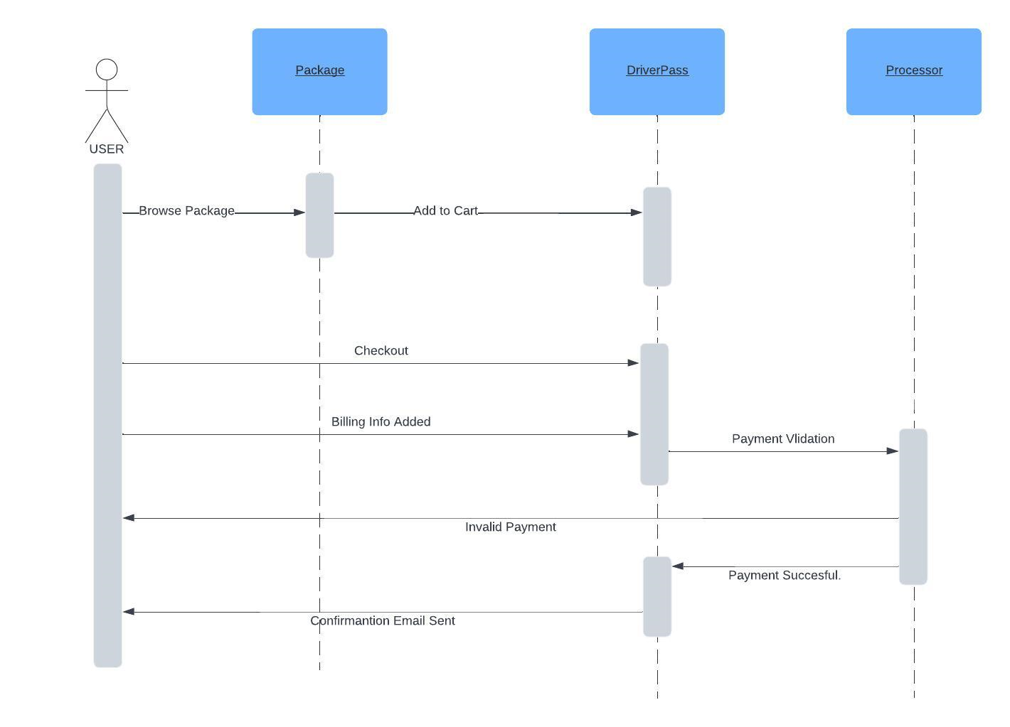*

### UML Class Diagram

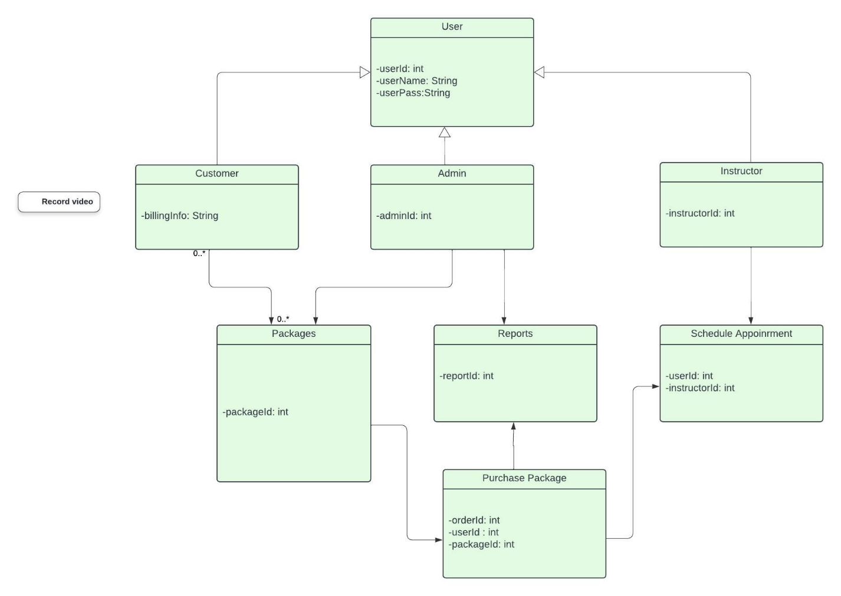

## Technical Requirements

***Hardware Requirements****.*

*Either a dedicated server or cloud based virtual machine*

*Device to access the system. (tablet, smartphone, laptop)*

***Software Requirements***

*Operating System to run server (Linux, Windows)*

*Web Server to handle HTTP requests*

*Database (SQL Server) to store user data*

***Infrastructure Requirements***

Domain Name

SSL Certificates to encrypt sensitive information

Cloud Hosting

Backup and Recovery